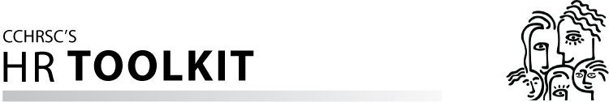TOOL: Sample Interview Questions
POSTED: March 2012

[Insert your organization’s name here]
INTERVIEW QUESTIONS
Asking the right interview questions will:
- Confirm the candidate's education, training, and experience listed in the resume
- Provide information about the candidate’s past performance and accomplishments
- Indicate the candidate's compatibility with the culture of your organization (for example, work pace, work style)
- Offer insights into the reasons behind the candidate's desire to change jobs
Responses to key questions should be probed further and confirmed through subsequent reference check
Questions NOT to ask
You must avoid asking unintentionally discriminatory questions. Questions to avoid include, but are not limited to:
- What year did you graduate from high school or post-secondary school?
- Where were you born?
- Where did you learn a foreign language?
- What are your child care arrangements?
- What are your religious practices?
- How many days did you miss because of illness last year?
- Do you have any disabilities?
- Have you ever been arrested?
- Are you planning to have children anytime soon?
- Are you responsible for parental care?
- Do you have senior parents or another family member that depends on you?

